Qlik Cloud  Mobile mashup for Anonymous Access  - Console Setup Instructions | 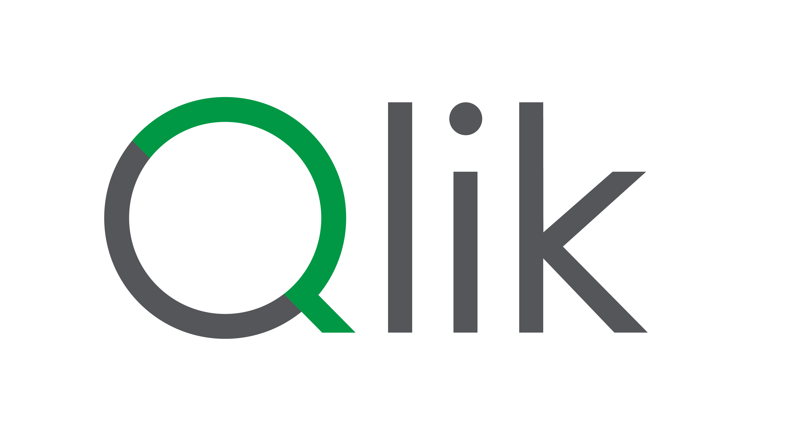
Using anonymous access is an excellent option when you want to easily share your content with general access.
We will focus this use case specifically on mashups and the Qlik Embed API..

Request an anonymous access tenant
If you don't already have one, you'll need to request it through our OKTA menu, in the Qlik Internal Employee Tenants and Keys app..
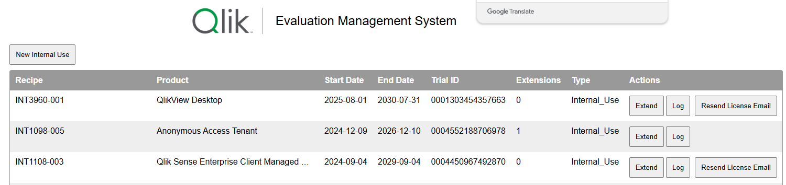
Publish and share the app
As you probably already know, the most important raw material for a mashup is still a Qlik Sense application.
It's Qlik's QIX engine that's responsible for responding effectively, just as we would with a browser and a desktop.
With a mashup, we simply offer access to that same app through a different environment.

Therefore, one of the first steps is to at least create a 'Managed' space and publish the app there.
Once published, we need to share it with the general public.
Try it:
Select Share and Manage access
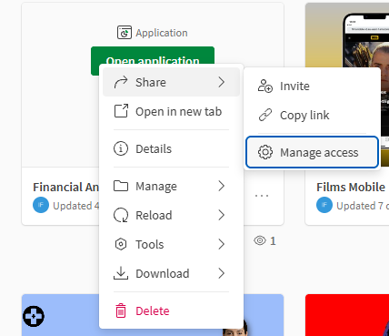
Turn the switch Any one with the link on.
Click on the weel icon and copy the app access code.
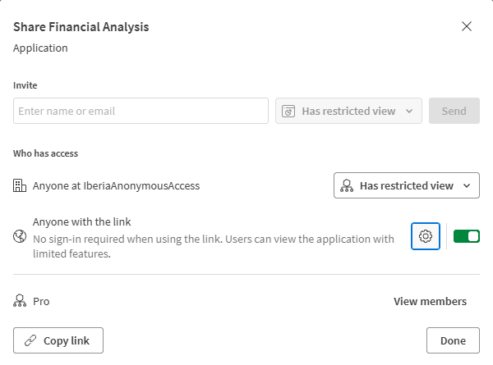 | 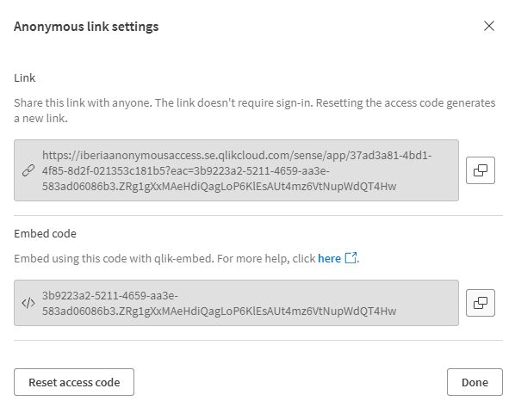
Keep this code, you’ll need it later.

Set up an anonymous ClientID
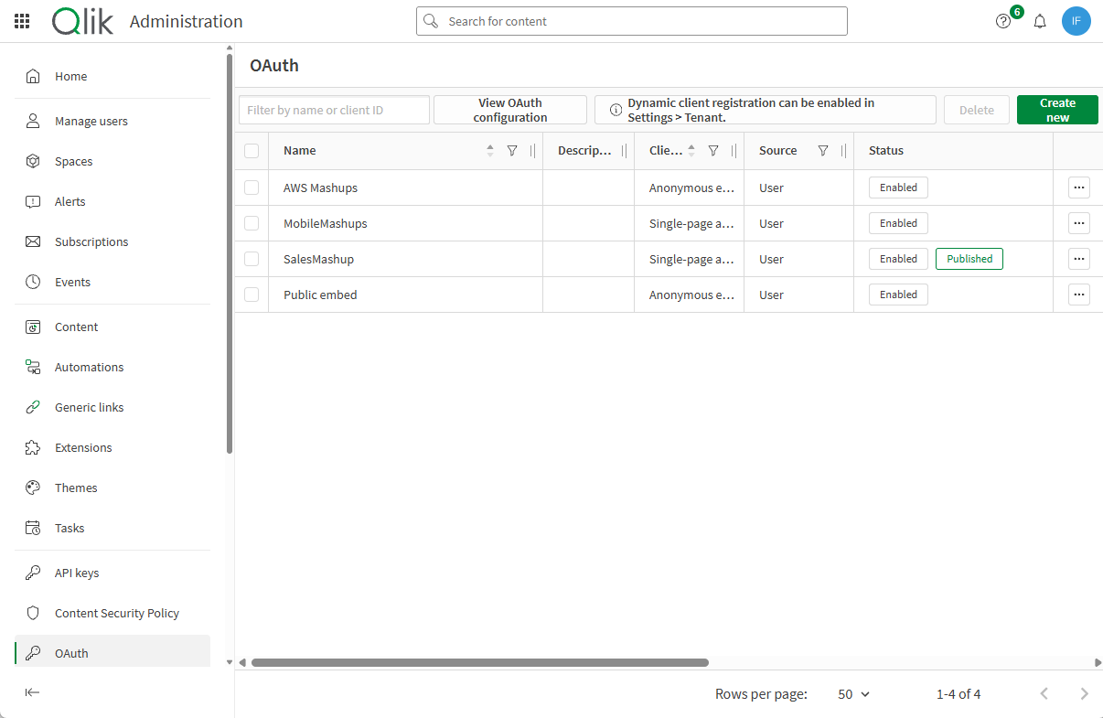
A clientId is needed to enable access through a mashup, no matter if it’s an anonymous or authenticated access.
In this case will set up an anonymous ClientId.
Try it: go to the administration console, search for the oauth option:
- Click on ‘Create New’, button on the top right.
- First option ‘Client Type’ = Anonymous Embed.
- Type a ‘Name’
- ‘Description’ is optional, but very recommended, as you will probably end-up with several clientids.
- Add an ‘Allowed origin’, that’s the URL of the repository you use to allocate your mashup.
Ex. If your mashup is in a S3 bucket
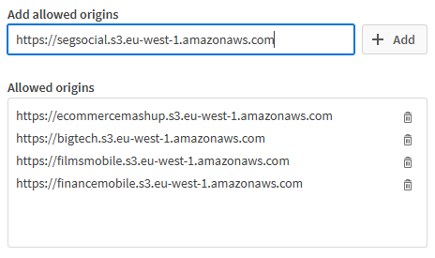
Ex. If your mashup is in a GitHub repository
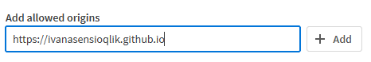
Keep in mind: you can only use a maximum of 5 repositories for each ClientId
- Click ‘Save’ and copy the ClientId

Have doubts about how to get that allowed origin URL?
Please follow the instructions in the document:
- Set up S3 bucket for Qlik Cloud mashups.docx
- or Set up Github pages for Qlik Cloud mashups.docx

